Final Project: Design Thinking

[Methods](https://static1.squarespace.com/static/57c6b79629687fde090a0fdd/t/58890239db29d6cc6c3338f7/1485374014340/METHODCARDS-v3-slim.pdf)

[Sprint (more methods)](https://static1.squarespace.com/static/57c6b79629687fde090a0fdd/t/58d3fa1e20099e1b0371a403/1490287182304/DESIGN+THINKING+PLAYBOOK.pdf)

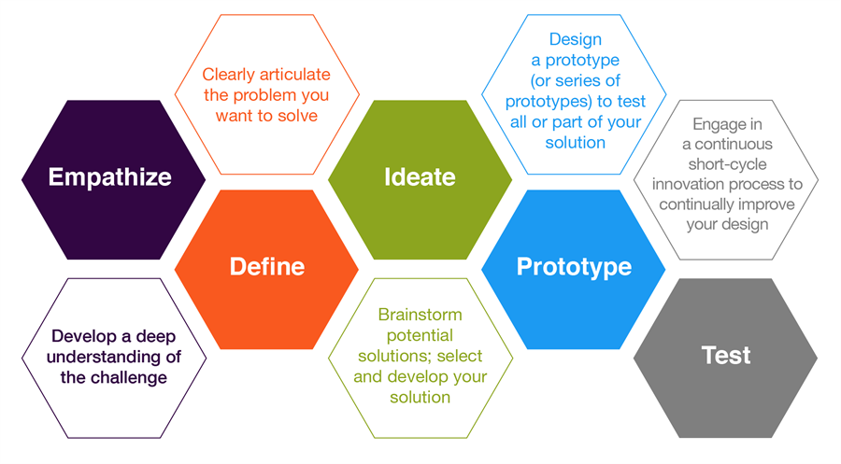

**Step 3: Ideate**

Ideation is about building innovation potential – not necessary about finding that one great idea.

Brainstorming gets you the seed of what can become innovative solutions (through prototyping and iteration).

(Regardless of what ideation technique you use), the core principle is to separate idea generation and evaluation.

Let yourself and your team explore, and turn off the critical part of your brain for just this period of time.

In this step, you aim to generate radical design alternatives (**going wide**) to explore the widest solution space possible. The more **diverse** the ideas (in number and scope), the more solutions you’ll explore in the prototyping stage.

**Goals:**

1. Step beyond obvious solutions, increase innovation potential.
2. Uncover unexpected areas of exploration
3. Harness the collective perspectives + strengths of your teams.

Brainstorming Guidelines:

* No judgment of both others’ ideas and your own
* Write down everything that comes to mind (within reason)
* Encourage the wild, the fantastical solutions.
* Build on the ideas of others
* Be visual
* Quantity over quality . . . yes, you heard that right.

General rules for brainstorming. Theme: spit out as much as possible, work together, and build on crazy ideas. Don’t judge them immediately, and even write down the ones you *know* are bad -- sometimes, you have to spit out multiple bad ideas in order to get to the good ones.

Make students aware that it’s expected that 90%+ of their ideas will be ridiculous -- the point is to come up with as many crazy solutions as possible. (Note: this doesn’t mean to intentionally look for bad ideas). Afterwards, you’ll continue working.

When you do the brainstorming activity, make it a competition to come up with the most ideas, and the craziest ones. This will make students more engaged! The suggested “high” target is 50 ideas in 20 minutes.

**Activity:** Let’s Plan a Trip (3 minutes - 3 minutes share)

Groups of 3-4 (ideally two teams)

* Brainstorm/Ideation activity to help get in the mindset
  + You’re going to brainstorm plans for a trip in your group
  + Throw out crazy ideas!
* Typically when people are planning things, they say “yes, but,” immediately evaluating ideas and shooting them down
  + **Optional:** test “yes, but” out (3 minutes), and debrief at the end the difference in the ideas generated
* This is harmful for brainstorming, so why don’t we try only saying “yes, and . . .” building off each others’ ideas?

1. Start with a place. Prompt the class:
   1. Where’s somewhere you’ve always wanted to go?
2. Ideally, students will chime in with “yes, and . . .” building off each other’s ideas.
3. It’s up to your discretion when to end it (try to end on a high note, hopefully something either crazy, funny, or memorable to enter the brainstorm on a high note)

DEBRIEF THE EXPERIENCE before moving on

Try to get students to separate idea creation and evaluation (no judgments allowed!)

Ex: Let’s go to Canada.

Yes, and we can ride mooses instead of driving or flying.

Yes, and we can go on vacation during the coldest winter in the last century.

Yes, and we should remember to bring our scuba gear to explore the beautiful beaches.

Yes, and we can escape the American presidency and become Canadians.

Yes, and . . .

**Activity:** Brainstorm (15 minutes)

(Split into project teams, have everyone find an empty space to put several dozen post-it notes on -- walls, floors, desks, etc…)

* Brainstorm! Remember:
  + Defer judgment
  + Quantity over quality
* Team with the most ideas after 15 minutes will win glory and honor for their team!
* Shoot for 50 ideas! No idea is too crazy.

Guiding questions if they get stuck: (adding and removing constraints, changing the lens with which we approach problems)

* How might we redefine [insert problem statement here]?
* How would you solve this problem with $1,000,000?
* How would you solve this problem with $100?
* How would you solve this problem tomorrow?
* What would Oprah do?
* How would Superman do it?
* How would you design it a hundred years from now?
* How would you grandma design it?
* How would you design for [problem] without technology?

**Activity:** Evaluate Ideas (5 minutes)

(Have students draw dots/make marks on their post-its)

“most impactful/innovative”

“most feasible idea” (implement it tomorrow!)

“most applicable/needed”

Everyone from a group votes once for each category

“Most impactful” == If it succeeded, how big of an impact could it have? Often a novel approach (innovative), like Tesla.

“Feasible” == What could I implement tomorrow? What are the easiest ideas to implement?

“Most applicable/needed” == What would be the most useful idea for my user?

A natural winner will likely arise, if not, use judgment to choose one